### 5 Core Values

Smyrna Elementary strives for success by following the Smyrna School District’s 5 core values:

**Perserverance**

**Responsibility**

**Integrity**

**Respect**

**Compassion**

## Smyrna Elementary School

# Smyrna Elementary School

# Acceptable Use Policy



Tel: 302-653-8588

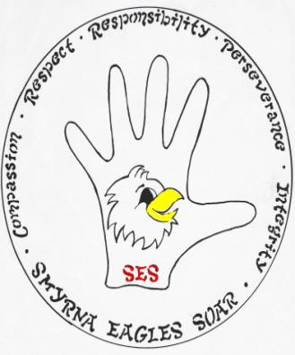

121 South School Lane

Smyrna, DE 19977

www.ses.smyrna.k12.de.us

Grades Pre-K through 4

Jaime Hurlock

### Rules & Guidelines



#### Use of email & internet

-you are responsible for what you send in your messages

-alert your teacher if you find inappropriate pictures or words in a message

-use of email for fundraising must be approved

-honor copyright laws when sending attachments

-do not sell anything online

-games, software, audio, video, or other online activities are for instruction only unless given special permission by a teacher

-all rules apply from student code of conduct

#### Consequences

If rules are violated, student will adhere to consequences stated in the school code of conduct. This could result in loss of privileges of computers in the Smyrna School District.

#### acceptable use policy

The Smyrna Elementary Acceptable Use Policy can be found in the Smyrna Elementary School Code of Conduct. Each student and parent is required to sign the form & return to the school before use of school technology.

All parents and teachers should review the acceptable use policy with students. No student shall use school computers without proper permission from a parent and teacher. Teachers are to adhere to the same policy as well as district technology policies in contract.

Parents: Be sure to sign & return the attached page so that your child may use the computers at school.

* School computers should only be used for school work. Personal use is allowed but should not:

-interfere with your schoolwork or other’s learning

-involve buying items online

-violate any of the rules contained in the student code of conduct or other State of Delaware Laws

-use streaming services such as listening to music, watching videos, downloading music or videos, and printing non-educational documents

* Students should use computers in a manner that they:

-never damage or alter equipment

-always have permission and a teacher’s supervision

-never logon using someone else’s password

-never are disruptive, or hurt someone’s feelings

-never bully or create a hostile school environment

* Students must:

-only create, edit, change, delete or hand-in their own computer work or quizzes

-never change computer settings

-never share personal information with anyone online